

**SOM 700- Managing Digital Products  
Group 2**

**Design Phase**

|  |  |
| --- | --- |
| **Amol Agarwal** | **23M2317** |
| **Bhavesh Yewale** | **23M2332** |
| **Ashutosh Raaj** | **23M2328** |
| **Kshitij Dwivedi** | **23M2357** |
| **Kedar Kamatekar** | **23M2356** |
| **Anish Singh** | **23M2321** |
| **Aastha Panbude** | **23M2303** |
| **Aavriti Dutta** | **23M2304** |
| **Saundrya Nair** | **23M2388** |
| **Vishnu Menon** | **23M2417** |
| **Vikas J** | **23M2415** |

**UI/UX Designs- Wireframes**

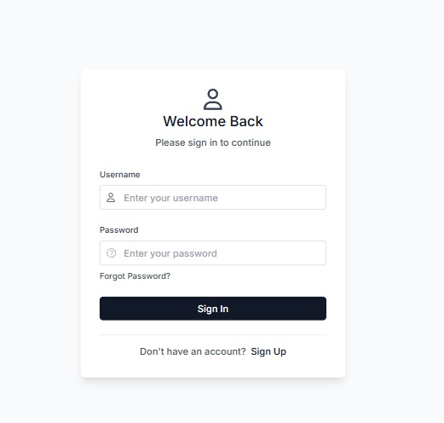

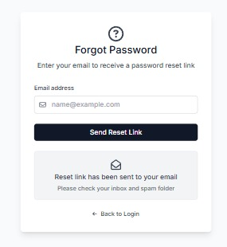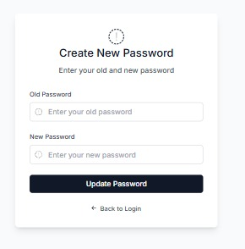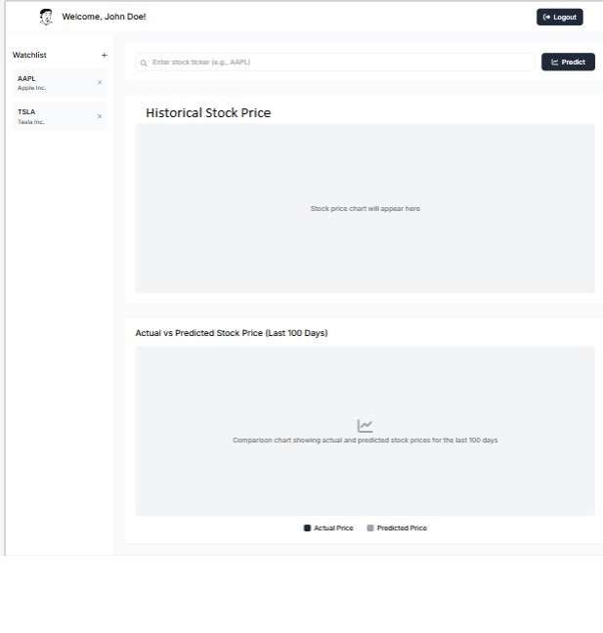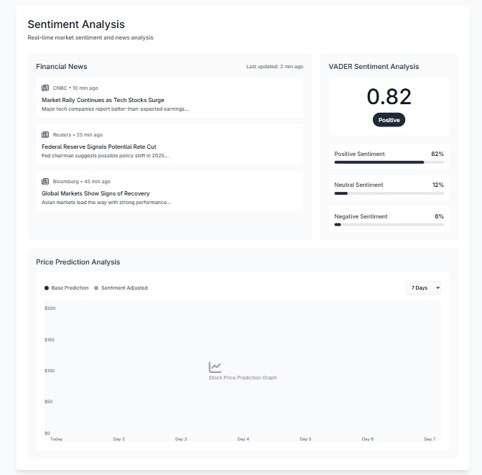

**Data Flow Diagrams  
Level 0**

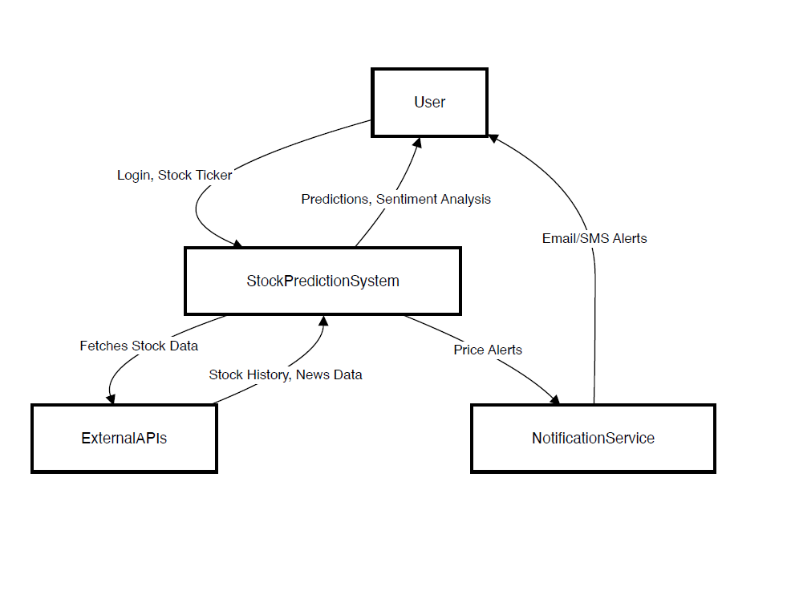

**Level 1**

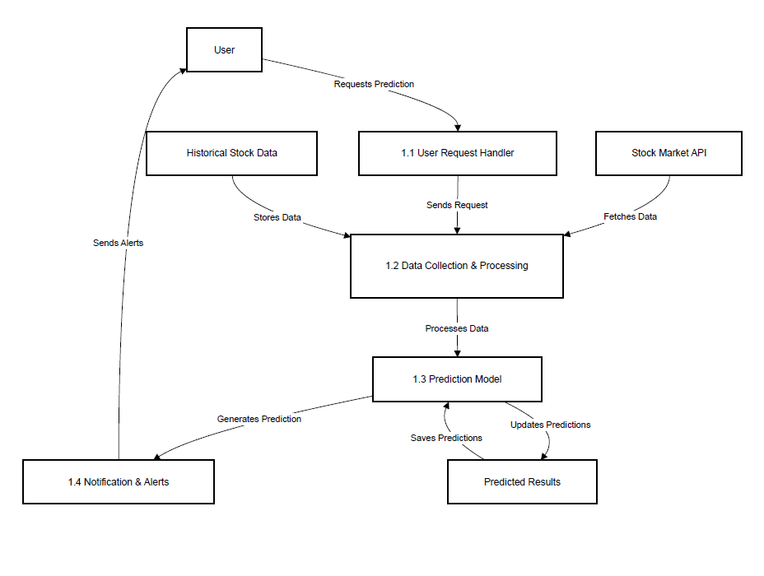

**Level 2**

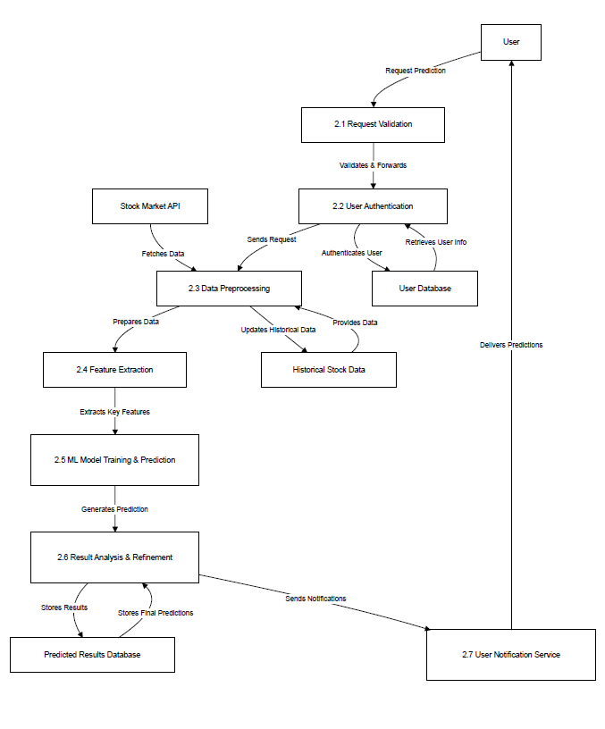

**Level 3**

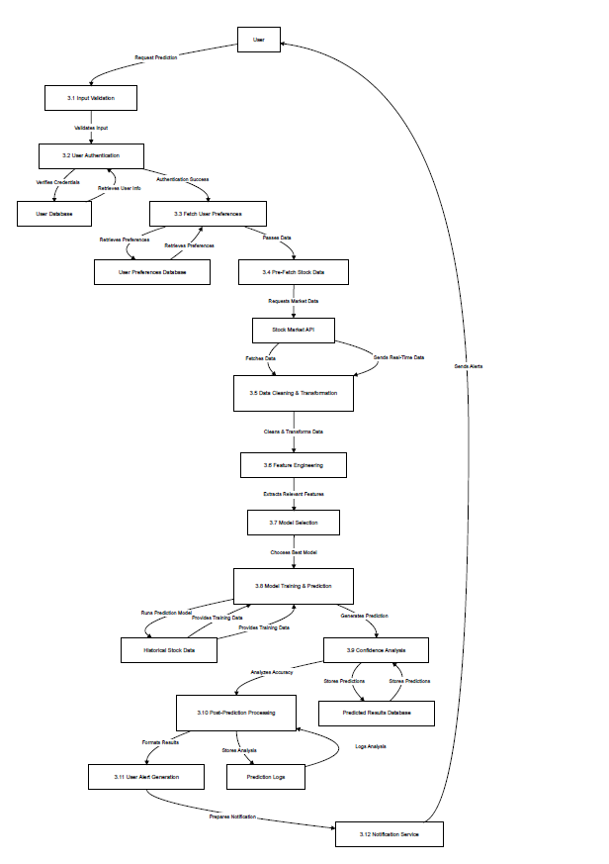

**Flowchart**